**Difference between HTTP1.1 vs. HTTP2**

**Introduction**: HTTP is the short form of Hypertext Transfer Protocol. It is foundation for World Wide Web. It is used by browsers in order to load the web pages. By using HTTP user sends the request to the server & the server sends the response to the user. There are several stages of development of HTTP but we will focus mainly on HTTP/1.1 & the new one is HTTP/2

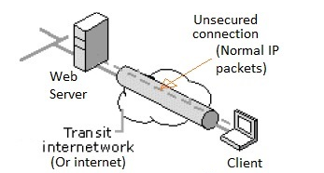

Example: Client browser sends HTTP request to web server once we enter URL such as "http://www.google.com". Web browser sends HTTP response to the client with the contents of the webpage.

So what is the difference, There are many advancement and the new feature was implemented in HTTP 2.0 , since HTTP 1.1 "practically" only allows one outstanding request per TCP connection. But with HTTP 2.0 we can have multiple requests at a time.

If you can see in example below, A web page comprising of two files:

1) style.css (to enhance the UI display)

2) Script.js (to make interactive web page)

When we use http 1.1 version, if you request web page at a one-time only 1 file is getting loaded on your UI, but with HTTP 2.0 both file will get loaded. Observe below screenshot

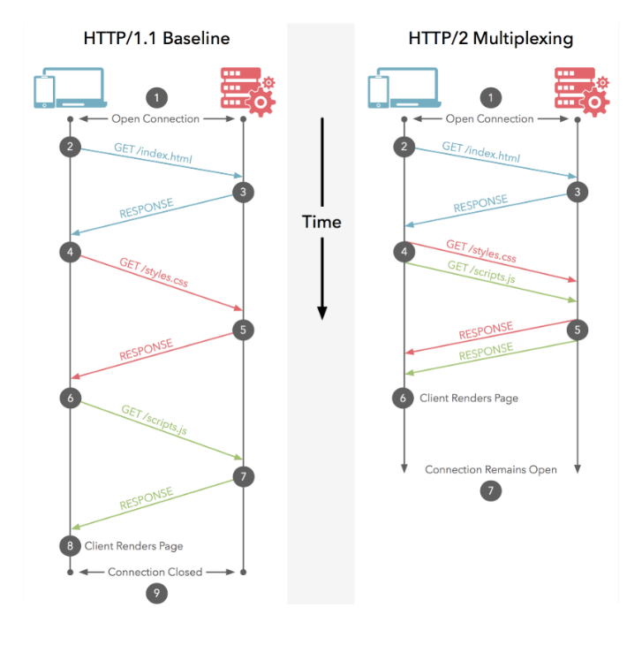

**HTTP 1.1 Protocol**

* It was released in 1997.
* It uses text based commands for HTTP requests.
* It added many performance enhancements e.g. caching, request pipelining, keep alive connections, transfer encoding, byte range requests etc.
* It can load one request at a time. Hence one request per one TCP connection is possible.
* It compresses data by itself.

**HTTP 2 Protocol**

* It was released in Feb. 2015 by IERF.
* It was developed over the SPDY protocol
* It is binary and not textual.
* It is fully multiplexed.
* It interleaves multiple requests/responses in parallel without blocking on anyone.
* It uses single TCP connection to deliver multiple requests/responses (in parallel).
* It uses header compression in order to reduce overhead.
* It uses HPACK for data compression.
* It allows servers to "push" responses into client caches proactively.
* It removes unnecessary HTTP/1.x work-around e.g. Image sprites, domain sharing etc. • It is less error prone than HTTP/1.

**This is important while testing web page performance and the speed of content delivery.**

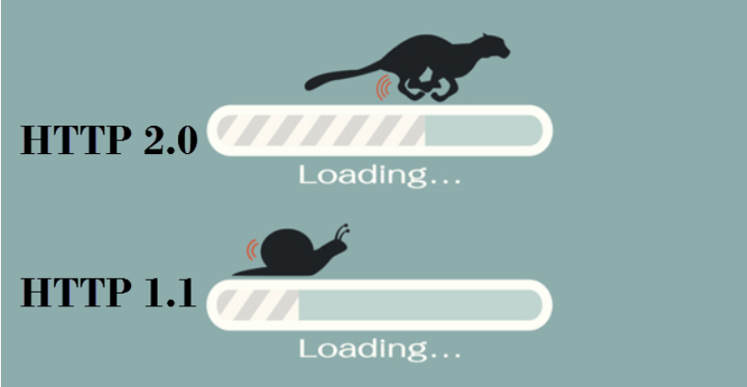

We can get to know what version of http your website is running on by inspecting network tab of your browser developer tool by F12

